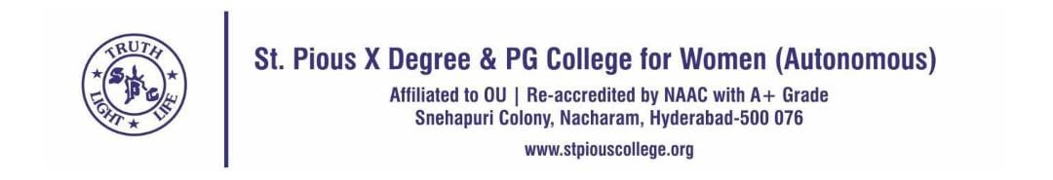
Report on Orientation Program: "Indian Educational System "Organised by IIC

Name of the Committee: IIC Committee

Name of the Activity: Orientation Program on "Indian Educational System"

Date: 30th July 2025

Occasion: NEP 2020 5th Anniversary Celebration

Target Audience: All life science students

Collaboration or MoU: NO

Resource persons: NEP Sarathi Ambassadors-Ms. Mounika, Ms. Meghana, and Ms. Glory

Venue: Siver Jubilee Hall

As part of the NEP 2020, 5th anniversary celebrations, an orientation program was conducted on 30th July 2025 focusing on the Indian Education System with an emphasis on the National Education Policy (NEP) 2020. The event was organized to raise awareness among students and promote the transformative vision of NΕΡ 2020.

The session was led by NEP Sarathi Ambassadors -Ms. Mounika, Ms. Meghana, and Ms. Glory - who eloquently highlighted the key reforms introduced under NEP 2020. The orientation aimed to empower students with insights into the evolving educational framework that fosters flexibility; skill development, and holistic learning.

Following the orientation, an engaging Just A Minute (JAM) session was conducted on the theme "Revolution in the Indian Education System". A total of 27 students actively participated, expressing their views and understanding of educational reforms, challenges, and future possibilities

The JAM session was judged by two esteemed academic leaders:

Dr. Komala, Dean of Academics

Dr. Sushama, Principal of Management

Their valuable feedback and encouragement further enriched the learning experience for all participants. The program successfully ignited intellectual curiosity and initiated meaningful discussion among students regarding India's educational transformation. It concluded with a vote of thanks and a call for student to become active contributors to the vision of NEP 2020

